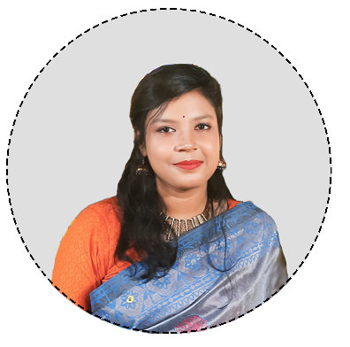

## **PUSHPITA ACHARJEE**

Present Address: 18/2,cherry blossom,

Tollabagh, Sobhanbagh, Dhaka :1207

Mobile: +8801991209725  
Email: [Acharjeepushpita021@gmail.com](mailto:Acharjeepushpita021@gmail.com)

Linkedin: <https://www.linkedin.com/in/pushpita-acharjee-b31207220/>

Results-driven professional with a background in microbiology and extensive experience in research, diagnostics, and data analysis. Seeking to contribute strong market intelligence, data-driven decision-making, and competitor analysis skills to Pharmaceuticals Industry .Eager to leverage a deep understanding of scientific products and market trends to drive growth and competitive advantage in the pharmaceutical sector.

**OBJECTIVES**

**EDUCATION**

2020-2021

**MS in Microbiology,** University of Chittagong

CGPA: 3.17  
Major: Advance cell and Molecular biology, Emerging Infectious Disease, Immuno-toxicology, Environmental Biotechnology, Virology and Oncology, Nano-biotechnology ; Biostatistics and Case report making.

2019

**B.Sc. in Microbiology,** University of Chittagong

2014

**HSC,** Chittagong Govt. Women College

2012

**SSC,** Bangladesh Mohila Samity Girls’ High School & College, Chittagong

**WORK EXPERIENCE**

June 2023 – March 2024

**JUNIOR EXECUTIVE (MICROBIOLOGIST)**

Ark Seafood Ltd, BSCIC Industrial Estate, Chittagong

* Conducted bacteriological identification tests and heavy metal detection tests to ensure product safety and compliance with health standards.
* Performed routine analyses such as Aerobic Plate Counts (APC), Biochemical Oxygen Demand (BOD), and Chemical Oxygen Demand (COD).
* Assisted in the implementation of quality control measures and standard operating procedures to improve laboratory efficiency.
* Collaborated with cross-functional teams to support product development, sales data analysis and ensure adherence to safety regulations.

**TRAINING & WORKSHOP**

2024

**AI in PUBLIC HEALTH**

Child Health Reseach Foundation (CHRF)

Granted Scholarship by 'Bill and Melinda Gates Foundation

2020

**GENOMIC DATA SCIENCE**

Coursera - Johns Hopkins University

2020

**MAKING ARCHITECTURE**

Coursera- IE School of Architecture & Design

**Training on Study Design and Sample Size Calculation**

ICDDR,B. Technical Training Unit

2024

**RESEARCH ACTIVITIES**

2020-2021

**RESEARCH ASSISTANT**

Bangladesh Undergraduate Research Organization

2020

**RESEARCH ASSISTANT**

Covid 19 specific diabetes worries among diabetic patients.

**LEADERSHIP ACTIVITIES**

2021

**ASSISTANT SECRETARY** (Publication and Publicity Department)

Chittagong University Scientific Society

2020

**GENERAL MEMBER**

Chittagong University Scientific Society

2020

**BYLC Career Bootcamp**

Bangladesh Youth Leadership Center, Dhaka.

**SKILLS (LABORATOR & TECHNICAL)**

* Bacterial Identification
* Laboratory Techniques
* Microscopy
* Molecular Biology
* DNA Analysis
* Data Analysis
* Media Preparation
* Isolation of Micro-organisms
* Differential and Structural Stains
* Bacterial Population Count
* Antimicrobiogram Skills
* Diagnostic Skills
* Environmental Monitoring

**Laboratory Skills:**

* GMP (Good Manufacturing Practices)
* GLP (Good Laboratory Practices)
* HACCP (Hazard Analysis Critical Control Point)
* Laboratory Handling Skills

**Quality Standards:**

* Stata
* R
* SPSS

**Data Analysis Software:**

**Software:**

* Google Analytics
* Microsoft Office
* Python
* C++

**Software:**

* Canva
* Photoshop
* Illustrator

**Languages:**

* Bangla
* English
* Turkish
* Japanese

**REFERENCE**

* **Dr. Md. Abul Manchur** ,Professor, Microbiology,University of Chittagong

Email: [manchur.mbio@cu.ac.bd](mailto:manchur.mbio@cu.ac.bd) , 01732750751

* **Dr. Md Imranul Haque** ,Associate Professor , Microbiology,University of Chittagong

Email: [Imran.mbio@cu.ac.bd](mailto:Imran.mbio@cu.ac.bd) , 01749073771

* **Md Nur Muhammad** ,Manager (QC), Ark Seafoods limited

01732750751

* **Mr. Apu Kumar Das,** Executive, Microbiology, Nipro JMI Company Limited

Email: [apukumar@gmail.com](mailto:apukumar@gmail.com)  
01720141857